

UGANDA INSTITUTE OF INFORMATION AND COMMUNICATIONS TECHNOLOGY
END OF SEMESTER ONE EXAMINATIONS
ACADEMIC YEAR 2025/2026
DEPARTMENT: ICT

SEMESTER: ONE

PROGRAMME(S): DIPLOMA IN INFORMATION COMPUTER SCIENCE (DCS)

YEAR OF STUDY: TWO

COURSE: DATABASE DESIGN II

COURSE CODE : ECE213
DATE: SATURDAY 13TH, DECEMBER 2023

TIME: 2:00 PM – 5:00 PM

DURATION: 3 HOURS
INSTRUCTIONS:
- This paper contains two Sections: A (40 marks) & B (60 marks).
- Attempt ALL questions in Section A, and ONLY THREE questions in Section B.
- All questions in Section B carry equal marks.
- Credit will be given for use of relevant examples and illustrations.
- Begin each number in Section B on a new page of the answer sheet.
- DO NOT write on this question paper.
SECTION A [40 MARKS]
Attempt ALL the Questions in this Section.

1. Which SQL statement is used to retrieve data from a database?
A. Get
B. Select
C. Retrieve
D. Pull

2. Which clause is used to filter rows in SQL?
A. Where
B. Having
C. Filter
D. Order

3. Which keyword sorts the result set in SQL?
A. Sort By
B. Order
C. Order By
D. Group By

4. Which command is used to delete a table completely?
A. Delete Table
B. Remove Table
C. Drop Table
D. Clear Table

5. Which SQL clause groups rows that have the same value?
A. Group By
B. Order By
C. Where
D. Having

6. What is the correct syntax to insert a new record?
A. Insert New Into Table
B. Insert Into Table Values(...)
C. Add Into Table (...)
D. Put Into Table (...)

7. Which operator is used to select values within a range?
A. Between
B. Within
C. Range
D. Limit

8. Which SQL function returns the number of rows?
A. Sum()
B. Count()
C. Rowcount()
D. Total()

9. Which command is used to update data in a table?
A. Modify
B. Update
C. Change
D. Alter

10. Which SQL statement is used to remove specific rows from a table?
A. Remove
B. Drop
C. Delete
D. Clear

11. What does the DISTINCT keyword do?
A. Deletes duplicate rows
B. Shows only unique values
C. Groups similar rows
D. Updates row values

12. Which wildcard selects any number of characters?
A. ?
B. *
C. %
D. #

13. What is a primary key?
A. A field that stores duplicate values
B. A field that uniquely identifies a row
C. A field used for sorting only
D. A foreign field

14. Which keyword adds a new column to a table?
A. Insert Column
B. Alter Table … Add
C. Update Table … Add Column
D. Modify Table

15. Which clause filters groups created by GROUP BY?
A. Where
B. Having
C. Filter
D. Limit

16. Which of the following is a DDL command?
A. Update
B. Delete
C. Insert
D. Create

17. Which command renames a table?
A. Rename Table
B. Alter Table … Rename To
C. Update Table Name
D. Change Table

18. What does a foreign key do?
A. Ensures values are unique
B. Links two tables
C. Speeds up searching
D. Deletes duplicate values

19. Which SQL keyword is used to remove duplicates in aggregate results?
A. Distinct
B. Unique
C. Filter
D. Clean

20. Which SQL statement creates a database?
A. Make Database
B. New Database
C. Create Database
D. Generate Database

21. Which function returns the highest value in a column?
A. Max()
B. High()
C. Top()
D. Upper()

22. Which command permanently removes a database?
A. Remove Database
B. Delete Database
C. Drop Database
D. Clear Database

23. What is the result of a CROSS JOIN?
A. Only Matching Rows
B. Rows With Nulls
C. Cartesian Product
D. Grouped Rows

24. Which SQL command changes the structure of a table?
A. Modify
B. Update
C. Alter Table
D. Change Row

25. What is the main purpose of normalization in a database?
A. To increase data redundancy
B. To reduce data redundancy and avoid anomalies
C. To make queries slower
D. To store data in a single table

26. A table is in First Normal Form (1NF) if:
A. It has no repeating groups and each cell contains a single value
B. All non-key attributes depend on the whole primary key
C. All transitive dependencies are removed
D. It has no foreign keys

27. Second Normal Form (2NF) is achieved when:
A. The table is in 1NF and has no partial dependencies
B. The table has no composite keys
C. The table has no NULL values
D. All non-key attributes depend on other non-key attributes

28. Which of the following describes a transitive dependency?
A. When attribute A depends on attribute B, and B depends on C
B. When an attribute depends on only part of the primary key
C. When two tables have the same primary key
D. When no attributes depend on the primary key

29. A table is in Third Normal Form (3NF) when:
A. It is in 2NF and has no transitive dependencies
B. It has at most one candidate key
C. All non-key attributes depend on each other
D. It contains no composite keys

30. In an ERD, an entity is best defined as:
A. A property of an attribute
B. A real-world object or concept that can be identified
C. A relationship between two attributes
D. A field used only for primary keys

31. Which of the following is an example of a derived attribute in an ERD?
A. Date of Birth
B. Student ID
C. Age (calculated from Date of Birth)
D. Name

32. A primary key in an ERD is used to:
A. Remove redundancy from an entity
B. Uniquely identify each entity instance
C. Link attributes with foreign keys
D. Show cardinality in a relationship

33. In an ERD, a relationship that links an entity to itself (e.g., Employee supervises Employee) is called:
A. Weak relationship
B. Transitive relationship
C. Recursive (Unary) relationship
D. Identifying relationship

34. Which of the following is not one of the ACID properties of a transaction?
A. Atomicity
B. Consistency
C. Isolation
D. Durability
E. Authentication

35. Atomicity ensures that:
A. Transactions do not violate database rules
B. Each transaction is treated as a single unit that either fully completes or fully fails
C. Intermediate states of a transaction are visible to others
D. Changes are permanently stored once committed

36. The property that ensures one transaction does not interfere with another is called:
A. Consistency
B. Isolation
C. Durability
D. Synchronization

37. A transaction is said to be durable when:
A. Its effects remain even after a system crash
B. It cannot be rolled back
C. It has not been committed yet
D. It is executed in parallel with others

38. Which database operation marks the successful end of a transaction and makes all changes permanent?
A. ROLLBACK
B. END
C. COMMIT
D. SAVEPOINT

39. Which of the following is the primary purpose of database security?
A. Improving query performance
B. Protecting data from unauthorized access
C. Ensuring database normalization
D. Reducing storage requirements

40. Which of the following best describes the role of a Database Administrator (DBA)?
A. Writing application-level business logic
B. Designing user interfaces
C. Ensuring database security, backup, tuning, and user management
D. Selling database software to clients

SECTION B [60 MARKS]
Attempt ONLY THREE Questions in this Section.
Question 1
The table below shows information about staff in one of the YMCA Centres. Use it to answer the questions that follow.
TABLE NAME: STAFF
STAFFID | FNAME | LNAME | SEX | DOB | DEPT | SALARY
YMCA001 | MARIA | MUSIME | F | 22/11/80 | IT | 3,000,000
YMCA002 | CHRIS | MUGASHA | M | 11/11/92 | ADMIN | 4,500,000
YMCA003 | JOHNSON | ATWIINE | M | 31/10/88 | ADMIN | 1,500,000
YMCA004 | JEAN | KAGYMCARE | F | 30/02/85 | IT | 6,000,000
YMCA005 | SANDRA | NAKITTO | F | 01/01/81 | HR | 7,000,000
YMCA006 | FRANCES | AGUTI | F | 14/11/85 | HR | 5,000,000
YMCA007 | FRANCIS | MUGIRA | M | 10/09/89 | PRODUCTION | 4,000,000
YMCA008 | JANECE | MUGAMBE | F | 02/03/86 | PROCUREMENT | 3,500,000
YMCA009 | JOANITA | OKOLI | F | 11/12/88 | ADMIN | 5,500,000
YMCA010 | KENNETH | MUSINGUZI | M | 10/12/86 | PROCUREMENT | 6,000,000

- Write the SQL statement that will create a Database called: YMCA_STAFF_DB 2 marks
- Write the SQL statements that will create the table STAFF, within the above database with STAFFID as the primary key. 2 marks
- Write the SQL statement that will show staff belonging to HR department 2 marks
- Write the SQL statement that will display unique values under DEPT column 2 marks
- Write the SQL statement that will return the list of staff that belong to ADMIN, HR, and IT departments 4 marks
- What would be the output/resulting relation at the execution of the following statements in MySQL:
- SELECT COUNT(distinct DEPT) FROM STAFF; 4 marks
ii) SELECT * FROM STAFF WHERE SEX= "F”; 2 marks
(iii) UPDATE STAFF SET LNAME= 'MATSIKO' WHERE STAFFID = “YMCA010; 2 marks
Question 2
- Write brief notes on the following, with an illustration where possible: (2 marks @)

- Entity type
- Relationship type
- Attribute
- Degree of a relationship
- Attribute domain

(b) Create an ER diagram for each of the following descriptions: (2 marks @)

- Each company operates four departments, and each department belongs to one company. (Note when the exact cardinality is known (in this example, 4) a value can replace the multiplicity range.
(ii) Each department in part (a) employs one or more employees, and each employee works for one department.

(iii) Each of the employees in part (b) may or may not have one or more dependants, and each dependant belongs to one employee.
(iv) Each employee in part (c) may or may not have an employment history.
- Represent all the ER diagrams described in (a), (b), (c), and (d) as a single ER diagram.

Question 3
a) Define Database Normalization 4 marks
b) Explain the purpose for database normalization 6 marks
c) Consider an unnormalized table that stores customer orders:

OrderID | Customer | Products
1 | John | Apples, Bananas, Oranges
2 | Alice | Grapes, Strawberries
3 | Bob | Lemons, Limes

Normalize the above table up to 2NF 10 marks
Question 4

- Describe what a superclass and a subclass represent. 2 marks
- Describe the relationship between a superclass and its subclass 4 marks
- Describe and illustrate using an example the process of attribute inheritance. 4 marks
- Study the diagram below and interpret it by identifying: 2 marks @
Entities
Relationships
Multiplicities
Generalization/Specialization concepts
Participation/ disjoint constraints

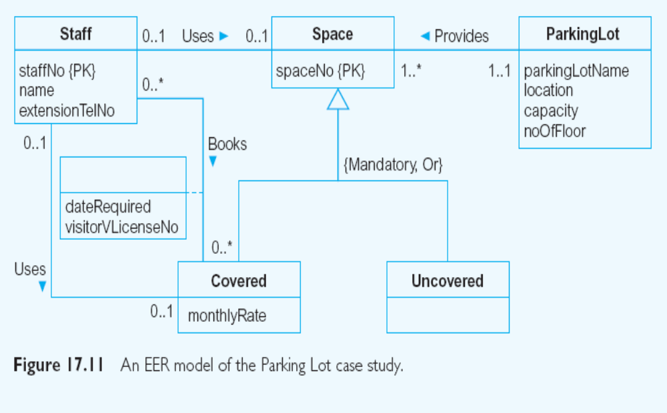

Question 5

a) Using an illustration, define a transaction 4 marks
b) Explain what is meant by transaction support 4 marks
c) Identify and explain 4 properties of transaction 4 marks
d) Identify and Explain threats to Computer Systems from the following dimensions:
- Hardware 2 marks
- DBMS and Application Software 2 marks
- Communication Networks 2 marks
- Database 2 marks

