
UGANDA INSTITUTE OF INFORMATION AND COMM. TECHNOLOGY
END OF SEMESTER 2 YEAR ONE & TWO EXAMINATION ACADEMIC YEAR 2024/2025

DEPARTMENT : MGT & ICT
YEAR OF STUDY : ONE
PROGRAM : DBA & ITB
COURSE : PRINCIPLES OF MARKETING
COURSE CODE : BAD 1201
DATE : FRIDAY 27TH, JUNE, 2025
TIME : 09:00-12:00 HOURS
DURATION : 3 HOURS

INSTRUCTIONS:
- This paper consists of TWO sections, SECTION A & B
- Answer FOUR (4) Questions in all.
- Section A is COMPULSORY, and any THREE questions from Section B
- Credit will be given for the use of relevant examples and illustrations.
- Mobile phones are NOT allowed in the exam room.
- DO NOT write anything on this question paper, rough work should be done in the answer booklet and cancelled through.
- Start a new number on a new fresh page.

SECTION A (THIS SECTION IS COMPULSORY)

QUESTION ONE

Read the following case study and answer the questions that follow;

Social Media Marketing Strategies for Mary Wedding Fashion Brands in Nakawa Market
Social media usage has become an integral element to the lives of many people across the world. In 2019 2.95 billion people were active social media users worldwide. This is forecast to increase to almost 3.43 billion by 2023 (Statistica, 2020b). Digital and social media marketing allows companies to achieve their marketing objectives at relatively low cost (Ajina, 2019). Facebook pages have more than 50 million registered businesses and over 88 % of businesses use Twitter for their marketing purposes (Lister, 2017). Digital and social media technologies and applications have also been widely used for creating awareness of public services and political promotions (Grover et al., 2024)
Online shopping has fully replaced our traditional methods of shopping, especially through social media marketing for fashion brands. People spend an increasing amount of time online searching for information, on products and services communicating with other consumers about their experiences and engaging with companies. Organizations have responded to this change in consumer behavior by making digital and social media an essential and integral component of their business marketing plans (Stephen, 2024)
Mary has created a successful social media presence for her wedding clothing line, by using a killer marketing strategy. The strategy with a rigid focus on wedding clothing trends depends on the brand and its target audience; it can be showcasing new season products online, live broadcasts of the fashion weeks and so much more. It is a known fact that fashion brands need to slay the social media game to gain attention in the never-ending medium of social platforms.
Mary uses a lot of platforms including tools and suggestions just for clothing brands meaning that she uses a different strategy on each platform to connect with her target audience. Mary found the general tips and tricks on what type of content she would want to create on which platform would work for her fashion brand.

Mary Fashion Brands Social Media Strategy
Mary created social media narratives and engage with people on these networks. Mary’s wedding fashion business (related to the clothing industry) has the following objectives:
- Reach the target audience,
- Competitor analysis,
- Brand awareness,
- Customer satisfaction,
- Increase sales,
- Build a community.
In other words, if the wedding fashion brand is absent from social media, it could legitimately be said to “not exist.” Anyone who pays attention to fashion has now adopted the practice of window-shopping on social media instead of going to malls to shop.
In the recent report by Influencer Marketing Hub (fashion bloggers and vloggers who have a large following), indicates that Mary’s influencer marketing is set to grow to approximately UGX 20 million in 2025. This represents a significant increase from the UGX 10 million that the industry was valued at in 2024. That means in the next years, social media influencers will Rema powerful force in fashion marketing; consumers will follow their favorite influencers for outfit ideas and inspiration, and they are increasingly making purchases through partnerships.
And yes, Instagram Stories and TikTok trend videos will keep being popular platforms for discovering new fashion trends and saving outfit ideas. Therefore, a solid social media strategy for fashion brands is crucial in our times.
Mary Wedding fashion business established a Social School for Women’s empowerment with the objective of empowering female victims of gender violence, through professional training and labor integration as brand ambassadors at the points of sale. In addition, the benefits of the implementation of the Social School for Women’s Empowerment have been analyzed from a triple point of view, i.e., women involved in the project (micro-level), participating organizations (meso-level), and society (macro-level). This social marketing and co-creation of value leads to the desired social impact, in this case, the improvement of economic, personal, and social–relational conditions of female survivors of gender violence. In this context, the marketing strategy (product, price, place, promotion, people, and process) is carried out to empower women and assess the results and possible improvements to be made in the future.
REQUIRED
- Identify four social media platforms that Mary’s Wedding Fashion must create to gain customer leads and enhance consumer engagement. (04 marks)
- In business, marketing and advertising brands are used. Enlighten the public about six (6) features of branding. (06 marks)
- Distinguish between the terms Ethics and Social responsibility as used in marketing. (04 marks)
- Give six (6) reasons why social responsibility is important for Mary’s wedding fashion business.
(06 marks)
- Summarize the factors that affect prices of Mary’s wedding fashions. (10 marks)
- Describe the challenges of digital marking to a Wedding Fashion Business like the one of Mary.
(10 marks)

SECTION B (ATTEMPT ANY THREE (3) QUESTIONSFROM THIS SECTION)

QUESTION TWO
- A business's ability to serve its customers and run its operations is influenced by a variety of internal and external environmental forces and factors. Discuss. (10 marks)
- As a student of marketing, explain to UICT why the Institute should carry out marketing environmental analysis. (10 marks)

QUESTION THREE

A target market is a subset of potential clients that you have specifically chosen to market your goods and services to. A Target Market is a subset of consumers who share similar demographics and are thought to be the most likely to purchase a new product from a business. Based on your knowledge of marketing;
- Identify the main factors used to select a Target Market. (12 marks)
- Describe the Market targeting strategies. (08 marks)

QUESTION FOUR
New products continue to fail at a disturbing rate. One source estimate that new consumer packaged goods (consisting mostly of line extensions) fail at a rate of 80 percent. Moreover, failure rates for new industrial products may be as high as 30 percent. As a consultant in marketing research,
- Explain why so many new products fail in the market. (10 marks)
- Describe the steps involved in developing a new product. (10 marks)

QUESTION FIVE

Marketing Communication mix refers to the different tools that a firm can adopt to inform, persuade, and remind the customer about the product and services it sells.
- Review the elements of promotional mix. (10 marks)
- Explain the need for Integrated Marketing Communications (IMC) in promoting organization products and services. (10 marks)

QUESTION SIX
In order to achieve customer satisfaction, this leads to the establishment of a unified, integrated, and optimal flow throughout the supply chain. Distribution channel decisions often involve long-term commitments to other firms.
- Review the objectives of distribution as used in marketing. (10 marks)
- Explain the key marketing decisions retailers make while distributing goods. (10 marks)

QUESTION SEVEN
- With the aid of a diagram, describe the components of a Marketing Information Systems.
(12 marks)
- Give eight (8) reasons why information is needed in organizations. (08 marks)

***END***

MARKING GUIDE -MARKETING FUNDAMENTALS

QUESION ONE
- social media platforms
- Facebook: It is the number one social media platform. A company can promote their product and services on Facebook.
- LinkedIn: Professional write their profiles on LinkedIn and can share with others. The company also build their profile and LinkedIn connect these two dots companies and professionals.
- Google+: It is Google’s social network, user can easily connect based on their common interest and friendship.
- .Twitter: Its strategy is to increase brand awareness and sales, attract new followers, and lead and boost conversions. , (4x1 =4 marks)
- Features of Branding:
- Creates a distinctive name, logo, and design for goods and services.
- Aids in developing a unique identity that customers will be able to recall.
- Distinguishes products from rivals in the market.
- Enables customers to recognise and select particular brands according to perceived worth and reliability.
- Brands arouse feelings in customers and foster relationships. , (6x1 =6 marks)

- Recurring sales are encouraged and trust is built through consistent branding.
- A product or service's perceived value can be increased by strong branding
- Customers frequently connect reputable brands with excellence and dependability.
- i) Marketing ethics refers to the principles and values that guide the behavior of marketers, emphasizing honesty, responsibility, fairness, and respect for consumers and society.
(2 marks)
Social responsibility means that organizations are part of a larger society and are accountable to that society for their actions. There are three concepts of social responsibility. Profit responsibility., stakeholder responsibility. And Societal responsibility
(2 marks)

ii) Importance of social responsibility
- Social responsibility empowers employees to leverage the corporate resources at their disposal to do good
- Being a socially responsible company can bolster a company's image and build its brand.
- Social responsibility programs can boost employee morale in the workplace and lead to greater productivity, which has an impact on how profitable the company can be.
- Businesses that implement social responsibility initiatives can increase customer retention and loyalty.
- Socially responsible companies have the opportunity to stand out from the competition because they cultivate superior and positive brand recognition.
- Improved public image.
- Increased brand awareness and recognition.
- Cost savings.
- An advantage over competitors.
- Increased customer engagement.
- Greater employee engagement.
- More benefits for employees.
- It encourages customer loyalty..
- It makes a business more sustainable..
- Customers are willing to pay more
- It attracts more investors.
- Opens up new opportunities/markets.
- Makes the world a better place. Businesses, (6x1 =6 marks)
- Factors Affecting Price of a Product
- Costs: A company's ability to charge a minimum price is directly impacted by the costs associated with marketing, distribution, and production.
- Market Demand: The sensitivity of customers to price changes is indicated by the price elasticity of demand.
- Competition: The acts and pricing policies of rivals in the market frequently have an impact on prices.
- Product Life Cycle: Pricing decisions may be influenced by a product's stage of introduction, growth, maturity, or decline.
- Perceived Value: A product's perceived value in relation to its price influences a customer's willingness to pay.
- Regulations and External Factors: Industry standards, economic conditions, and legal and regulatory restrictions can all have an impact on pricing strategies.
- Marketing Objectives: Pricing can be used to accomplish a variety of marketing objectives, including market penetration, market share maintenance, and skimming.
- . Marketing Mix Strategy
- Organizational Considerations
- Consumer Perception of Price and Value: (10 x 1= 10 marks)

- Challenges /Disadvantages of digital marketing
- Some of the downsides and challenges of digital marketing you should be aware of include:
- Skills and training
- Time consuming.
- High competition
- Complaints and feedback
- Security and privacy issues
- Increased Integration with Social Networks.
- Concern on Internet security
- Mismatch in the products ordered and delivered:
- Lack of face-to-face contact:
- Impersonal service:
- Sometimes customers perceived this as just too impersonal or uncaring.
- Lack of Trust:
- Know-It-Alls:
- Customer Expectations: Never before customers had expected too much.
- Traditional advertising (10 marks)

QUESTION TWO
  - environmental forces and factors.

Internal environment
- System of values
- Goals, mission, and vision
- Structure of organisations
- Business ethos
- Style of management 3x1=3marks

External Marketing Environment:

Micro Environment:
    - Customers
    - Suppliers
    - Competitors
    - Employees
    - Shareholders
    - Media 2x 1=2 marks

Macro Environment:
- Demographic Environment
- Economic Environment
- Natural Environment
- Technological Environment
- Political Environment
- Socio - Cultural Environment 5x1 =5 marks

b) The marketing environmental analysis will help the marketer to:
- Become well acquainted with the changes in the environment.
- Gain qualitative information about the business environment; which will help him to develop strategies in order to cope with ever changing environment.
- Conduct marketing analysis in order to understand the markets needs and wants so as to modify its products to satisfy these market requirements.
- Decide on matters related to Government-legal-regulatory policies in a particular country so as to formulate its strategies successfully amidst these policies.
- Allocate its resources effectively and diversify either into a new market segment or totally into a new business which is outside the scope of its existing business.
- Identify the threats from the environment in terms of new competitors, price wars, competitor’s new products or services, etc.; and prepare its strategies on the basis of that.
- Identify the opportunities in the environment and exploit these opportunities to firm’s advantage. These opportunities can be in terms of emergence of new markets; mergers, joint ventures, or alliances; market vacuum occurred due to exit of a competitor, etc.
- Identify its weaknesses such as lower quality of goods or services; lack of marketing expertise; or lack of unique products and services; and
- prepare strategies to convert its weaknesses into strengths. ix. Identify its strengths and fully exploit them in firm’s advantage. These strengths can be in terms of marketing expertise, superior product quality or services, or giving unique innovative products or services.

QUESTION THREE
- The main factors used to select a Target Market :
- Lifestyle of Consumers
- Age group of Consumers
- Income of Consumers
- Spending capacity of Consumers
- Education and Profession of the People
- f Gender
- Mentality and Thought process of the consumers (6x2 = 12 marks)
- The main strategies of Target Market are :
- Undifferentiated (Mass) Marketing : It is a marketing strategy that aims to reach as large an audience as possible. Instead of dividing the market into segments, it treats all buyers as a homogeneous group and market them similarly. It is also known as Mass marketing
- Differential (Segment) Marketing: It is an approach to marketing that appeals to niche market or different types of customers. It is the strategy in which a specific marketing mix is designed for every segment.
- Focus/Niche Marketing: It is a strategy or method in which marketers apply to determine the niche market to target. All the focus is on how to develop, market, and sell products in the niche market. A Niche market is identifiable by specific consumers, geographic areas, and unique product lines.
- Customized (micro) Marketing : It is a type of marketing that is tailored according to the specific needs of a company or individual. It considers the objectives of the business or the individual, the target market, and the budget.

(4 X 2 = 8 marks)

QUESTION FOUR
- Why many new products fail.
- A high-level executive might push a favorite idea despite poor marketing research findings.
- The costs of product development are higher than expected,
- Competitors fight back harder than expected
- Failure to Understand Consumer Needs and Wants
- Targeting the Wrong Market
- Fixing a Non-Existent Problem
- Incorrect Pricing
- Weak Team and Internal Capabilities
- Prolonged Development or Delayed Market Entry
- Poor Execution

- Stages n New Product Development:

Idea generation

Product definition

Prototyping iv. Initial design

Validation and testing

Commercialization
- Idea generation
- . Idea Screening
- Concept Development and Testing
- Marketing strategy Development
- Business Analysis
- Product Development
- Test Marketing
- Commercialization

QUESTION FIVE
- Elements of the Promotional Mix
:
- Advertising
- Personal selling
- Sales promotion.
- Public relations
- Direct marketing *(5x2 =10 marks)
- The Need for Integrated Marketing Communications (IMC)
- . It leads to better Results
- It Reduces Costs
- It Promotes Consistency
- Customer satisfaction
- Boosted brand awareness
- Repeated success (5 X2 =10 marks)

QUESTION SIX

In order to achieve customer satisfaction, this leads to the establishment of a unified, integrated, and optimal flow throughout the supply chain.
a) Objectives of Distribution Logistics :
    - Promote distribution efficiency in process of supply chain.
    - Meet demand of client.
    - Reduce various product damage
    - Reduction in Operational Cost
    - Effective flow of information (
    - Helps in Quality control
    - Control Carbon emissions for Environmental protection. ( 5x2 =10 marks)
b) RETAILER MARKETING DECISIONS
- Customer Satisfaction
- Acquiring the Right Products
- Product Presentation
- Traffic Building
- Layout
- Site selection for retail Location
- Keeping Pace With
- Price Decision
- Promotion Decision (5x2 = 10 marks)

QUESTION SEVEN
a)
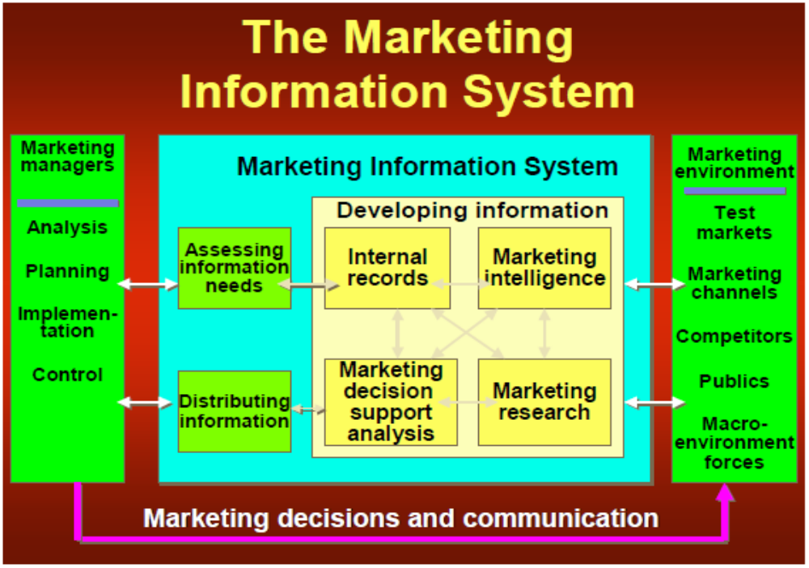
(12 marks)
b) Why is information needed in organizations?
Managers mostly want to be able to predict the future of a company and its products. That future embraces the total market demand and the nature of such demand, the company’s share by brand and what competitors will be doing. They want this information so they can chart their own firm’s future and thereby are proactive rather than be forced into reacting to a competitor’s actions.

To operate properly in the marketing environment, it is necessary to obtain adequate information before and after making decisions. Some reasons advanced for obtaining information include: -

- To be able to measure performance
- To gain support from decision makers.
- Enable marketers to verify intuition and guesswork.
- Gain competitive advantage
- Reduce financial and other business risks
- To determine consumer attitudes
- Improve advertising credibility
- Gain more knowledge about the marketing environment.
- Improve effectiveness and efficiency in implementation of all activities
- To be able to coordinate organisational strategy
- Increases the probability of successful marketing
- Assess results or impact of the marketing effort.
- Receive feedback from customers about the Company’s products (8 x 1= 8 marks)

